***Name :*** Omar Ahmed Sayed Zaki Elhalawany.

***B.N:***  19.

***E-mail :*** omar195632@feng.bu.edu.eg

***Topic :*** Artificial Intelligence.

***Application brief:*** Artificial intelligence is the behavior and specific characteristics of computer programs that make them mimic human mental capabilities and working patterns. Among the most important of these characteristics is the ability to learn, infer, and react to situations not programmed in the machine. However, this term is controversial due to the lack of a specific definition of intelligence.

And artificial intelligence is a branch of computer science. Artificial intelligence is defined by many literature as "the study and design of smart clients", and a smart customer is a system that absorbs its environment and takes situations that increase its chance of success in achieving its mission or the mission of its team.

This definition, in terms of goals, actions, perception, and environment, refers to Russell & Norvig (2003) and other definitions also include knowledge and learning as additional criteria. Computer scientist John McCarthy originally coined this term in 1956, and he defined himself as "the science and engineering of making smart machines." Andreas Kaplan and Michael Heinleen define artificial intelligence as "the system's ability to properly interpret external data, learn from this data, and use that knowledge to achieve specific goals and tasks through flexible adaptation."

This field was founded on the assumption that the intelligence kingdom can be described accurately enough to simulate the machine. This raises a philosophical debate about the nature of the human mind and the limits of scientific approaches, issues that have been discussed in legendary, fictional and philosophical discussions and tales from ancient times. Controversy also revolves around what intelligence and its types a person possesses, and how they simulate a machine. Artificial intelligence has been and continues to cause highly optimistic ideas, and has suffered severe setbacks throughout history, and today it has become an essential part of the technology industry, bearing the brunt of the most difficult problems in modern computer science.

AI research is highly specialized and technical, to the point that some critics criticize the "disintegration" of this field. AI sub-domains center around specific problems, the application of special tools and ancient theoretical differences of opinion. Major problems with artificial intelligence include capabilities such as logical thinking, knowledge, planning, learning, communication, perception, and the ability to move and change things. And general intelligence (or “strong artificial intelligence”) remains a long-term goal of some research in this field.

***Screen shots:***

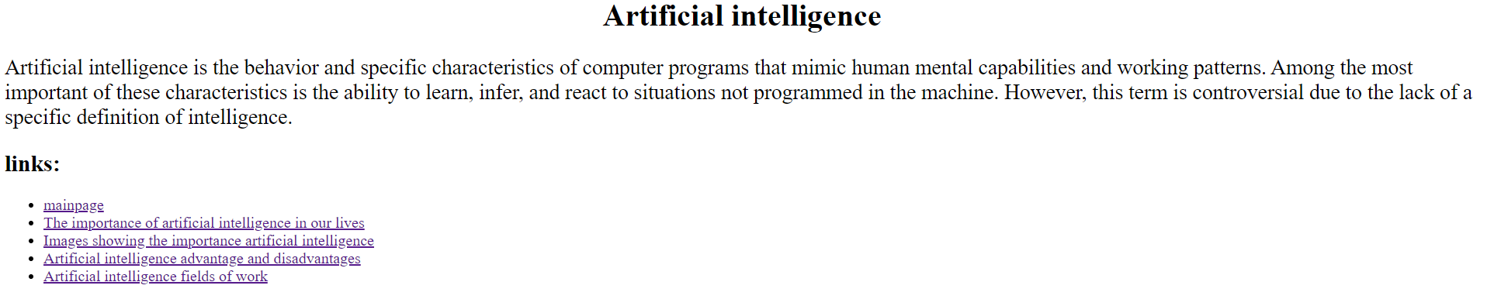

***Source code :***

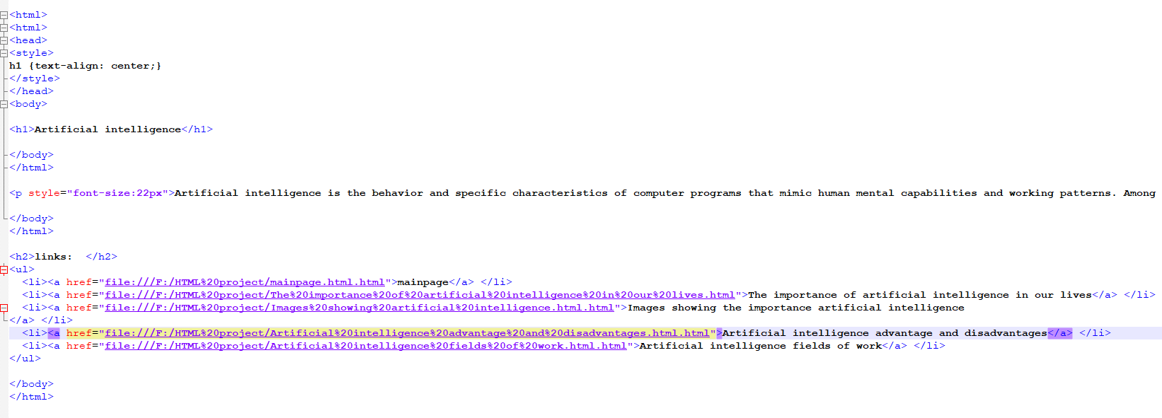

***Screen shots 2 :***

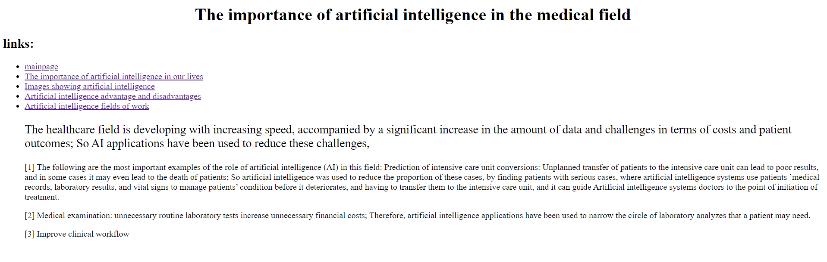

***Source code 2 :*** 